***JAZZ BAND ENTRY FORM – March 14th, 2026***

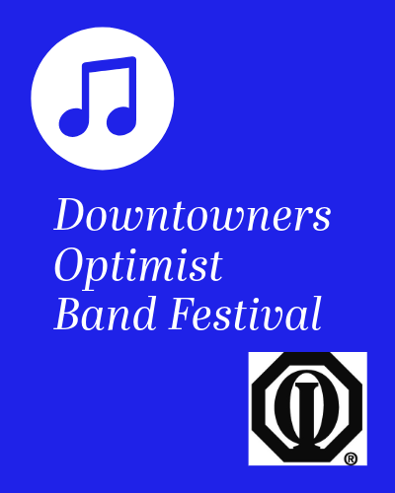

**Name of Band______________________________________________________________**

(as it is to appear in program)

**Band Director___________________________**

**Email_____________________________Cell Phone_____________________**

**Number of Members________** **City______________________________________**

**Earliest arrival time? _______________Latest departure time?____________________**

**Out of town Bands, please indicate if you have other activities in Regina or staying overnight.**

**___________________________________________________________________________**

**Performance Preference Morning _____________ Afternoon__________________**

**MULTIPLE BANDS PERFORMING: Each group rotation takes approximately 2.5 hours**

**Any mobility issues?**

My first selection is: _______________________________________________________________________________

My second selection is: ________________________________________________________________

My third selection is: __________________________________________________________________

* Please note, you will need to provide two scores for each selection.

**PLEASE NOTE: *Venue TBA* Make a day of it!!**

***Concert by Regina Jazz Orchestra to be held at 7PM!!***

**Entries Due: *December1st, 2025*** **Registration Fees (all groups):**

**Scheduling Date:** Before Christmas SBA member rate: $450.00 Non-member rate: $550.00

Out of Province Bands, please use SBA rate

**Non-refundable after Monday, February 15th, 2026**

Mail Cheques (Payable to Downtowners Optimist Band Festival) and Registrations to:

Downtowners Optimist Band Festival

C/O Lyle Merriam ([dlmerriam@sasktel.net](mailto:dlmerriam@sasktel.net)) ((306) 536-7683)

Box 82 Station Main

White City, Saskatchewan S4L 5B1

Alternately, email your registration form to [optimistbandfestival@gmail.com](mailto:optimistbandfestival@gmail.com) and follow with payment

All entries (mailed or emailed) will be acknowledged via email

**Payment be received in order for your group to be scheduled for performance.**

